# Graphs and tables

Table 1 Characteristics of the population – Source: RUME (2010) and NEEMSIS-1 (2016-17); author’s calculations.

|  |  |  |  |  |  |  |  |  |  |  |  |
| --- | --- | --- | --- | --- | --- | --- | --- | --- | --- | --- | --- |
|  | Dalits | |  | Middle | |  | Upper | |  | Total | |
|  | 2010 | 2016-17 |  | 2010 | 2016-17 |  | 2010 | 2016-17 |  | 2010 | 2016-17 |
| Number of households | n=194 | n=236 |  | n=158 | n=199 |  | n=53 | n=57 |  | n=405 | n=492 |
| **Households characteristics** |  |  |  |  |  |  |  |  |  |  |  |
| Household size (mean) | 4.6 | 4.9 |  | 4.7 | 4.6 |  | 4.3 | 4.0 |  | 4.6 | 4.7 |
| House type (%) |  |  |  |  |  |  |  |  |  |  |  |
| *Concrete house* | 54.6 | 39.8 |  | 72.8 | 57.8 |  | 84.9 | 75.4 |  | 65.7 | 51.2 |
| *Government/green house* | 17.5 | 26.7 |  | 0.6 | 10.0 |  | 1.9 | 10.5 |  | 8.9 | 18.1 |
| *Thatched roof house* | 27.8 | 33.5 |  | 26.6 | 32.2 |  | 13.2 | 14.0 |  | 25.4 | 30.7 |
| Land owner (%) | 41.7 | 19.9 |  | 70.9 | 44.2 |  | 50.9 | 28.1 |  | 54.3 | 30.7 |
| Size own land (acre) |  |  |  |  |  |  |  |  |  |  |  |
| *Mean* | 1.4 | 1.5 |  | 2.1 | 2.6 |  | 3.4 | 4.6 |  | 2.0 | 2.5 |
| *SD* | 1.0 | 1.9 |  | 1.6 | 2.7 |  | 2.7 | 4.0 |  | 1.7 | 2.8 |
| *Median* | 1.0 | 1.0 |  | 2.0 | 2.0 |  | 2.0 | 4.8 |  | 1.5 | 1.0 |
| Nber income source (mean) | 3.6 | 4.7 |  | 3.1 | 4.1 |  | 2.8 | 3.1 |  | 3.3 | 4.3 |
| Share of non-agri income* | 57.4 | 67.1 |  | 51.9 | 64.9 |  | 73.2 | 80.6 |  | 57.3 | 68.0 |
| Annual income (1,000 INR) |  |  |  |  |  |  |  |  |  |  |  |
| *Mean* | 78.7 | 111.9 |  | 80.0 | 118.5 |  | 94.6 | 117.3 |  | 81.3 | 115.2 |
| *SD* | 54.7 | 210.9 |  | 48.3 | 137.5 |  | 100.1 | 85.9 |  | 60.4 | 172.5 |
| *Median* | 66.0 | 67.7 |  | 70.0 | 82.1 |  | 80.0 | 102.6 |  | 68.0 | 77.3 |
| Assets (1,000 INR) |  |  |  |  |  |  |  |  |  |  |  |
| *Mean* | 770.0 | 351.7 |  | 1,684.7 | 1,098.3 |  | 2,047.3 | 1,267.9 |  | 1,294.0 | 760.0 |
| *SD* | 945.0 | 675.0 |  | 1,613.7 | 1,866.8 |  | 2,728.2 | 2,002.4 |  | 1,631.8 | 1,495.7 |
| *Median* | 241.0 | 171.9 |  | 1,267.2 | 434.7 |  | 717.0 | 452.3 |  | 701.0 | 258.8 |
| Assets without land (1,000 INR) |  |  |  |  |  |  |  |  |  |  |  |
| *Mean* | 196.1 | 176.9 |  | 265.2 | 362.7 |  | 320.8 | 452.5 |  | 239.4 | 284.0 |
| *SD* | 108.3 | 148.3 |  | 150.1 | 559.2 |  | 162.2 | 382.7 |  | 140.6 | 405.8 |
| *Median* | 179.0 | 147.2 |  | 236.5 | 230.1 |  | 302.0 | 397.5 |  | 195.5 | 183.0 |
| **Household head characteristics** |  |  |  |  |  |  |  |  |  |  |  |
| Male (%) | 91.2 | 89.66 |  | 94.30 | 93.40 |  | 98.11 | 96.49 |  | 93.33 | 91.98 |
| Age (mean) | 46.7 | 50.38 |  | 48.16 | 52.01 |  | 51.77 | 55.67 |  | 47.94 | 51.66 |
| Education (%) |  |  |  |  |  |  |  |  |  |  |  |
| *Below primary* | 55.1 | 57.8 |  | 41.8 | 37.6 |  | 35.8 | 22.8 |  | 47.4 | 45.5 |
| *Primary completed* | 19.1 | 17.7 |  | 18.3 | 26.9 |  | 22.6 | 26.3 |  | 19.3 | 22.4 |
| *High school* | 22.2 | 19.4 |  | 36.7 | 28.4 |  | 39.6 | 36.8 |  | 30.1 | 25.1 |
| *HSC/Diploma* | 2.6 | 4.3 |  | 2.5 | 5.6 |  | 0.0 | 12.3 |  | 2.2 | 5.8 |
| *Bachelors* | 0.5 | 0.4 |  | 0.0 | 1.0 |  | 1.9 | 1.7 |  | 0.5 | 0.8 |
| *Post graduate* | 0.5 | 0.4 |  | 0.6 | 0.5 |  | 0.0 | 0.0 |  | 0.5 | 0.4 |
| Note: *Share of non-agricultural activity in the total income of the household. | | | | | | | | | | | |

Table Purpose of loans -- Source: RUME (2010) and NEEMSIS-1 (2016-17); author's calculations.

|  |  |  |  |  |  |  |  |  |  |  |  |  |
| --- | --- | --- | --- | --- | --- | --- | --- | --- | --- | --- | --- | --- |
|  |  | % of loans | |  | % of HH using it | |  | Mean (1,000 INR) | |  | % in the total volume of loans | |
|  |  | 2010 | 2016 |  | 2010 | 2016 |  | 2010 | 2016 |  | 2010 | 2016 |
| Economic investment |  | 24.4 | 14.1 |  | 56.5 | 30.4 |  | 28.5 | 70.5 |  | 32.7 | 26.4 |
| *Agriculture* |  | *19.4* | *8.9* |  | *47.9* | *18.5* |  | *25.3* | *62.7* |  | *23.1* | *14.9* |
| *Investment* |  | *5.0* | *5.2* |  | *14.8* | *14.0* |  | *41.0* | *83.8* |  | *9.6* | *11.5* |
| Current expenses |  | 36.7 | 32.0 |  | 80.5 | 65.3 |  | 11.7 | 19.5 |  | 20.0 | 16.7 |
| *Family* |  | *27.0* | *26.7* |  | *73.3* | *57.5* |  | *10.7* | *18.4* |  | *13.5* | *13.1* |
| *Repay previous loan* |  | *4.5* | *4.7* |  | *18.5* | *16.4* |  | *18.8* | *27.7* |  | *3.9* | *3.4* |
| *Relatives* |  | *5.2* | *0.6* |  | *23.7* | *2.0* |  | *10.7* | *11.7* |  | *2.6* | *0.2* |
| Human capital |  | 17.9 | 15.9 |  | 53.3 | 37.8 |  | 24.2 | 29.2 |  | 20.4 | 12.4 |
| *Health* |  | *10.3* | *7.7* |  | *35.1* | *20.1* |  | *27.1* | *26.7* |  | *13.2* | *5.5* |
| *Education* |  | *7.6* | *8.2* |  | *26.7* | *21.8* |  | *20.2* | *31.6* |  | *7.2* | *6.9* |
| Social and ritual events |  | 11.4 | 23.2 |  | 39.5 | 44.8 |  | 25.5 | 42.8 |  | 13.7 | 26.3 |
| *Ceremonies* |  | *3.5* | *6.3* |  | *15.6* | *20.5* |  | *13.0* | *21.2* |  | *2.2* | *3.5* |
| *Marriage* |  | *7.0* | *15.6* |  | *22.7* | *26.7* |  | *33.2* | *53.7* |  | *10.9* | *22.3* |
| *Death* |  | *0.9* | *1.3* |  | *3.7* | *4.5* |  | *14.4* | *14.6* |  | *0.6* | *0.5* |
| Housing |  | 9.6 | 13.3 |  | 29.4 | 28.1 |  | 29.1 | 39.6 |  | 13.1 | 14.1 |
| Other |  | 0.0 | 1.5 |  | 0.0 | 4.9 |  | 29.1 | 99.5 |  | 0.0 | 3.9 |
| *No reason* |  | *0.0* | *0.2* |  | *0.0* | *0.6* |  | *0.0* | *51.8* |  | *0.0* | *0.2* |
| *Other* |  | *0.0* | *1.3* |  | *0.0* | *4.3* |  | *0.0* | *104.8* |  | *0.0* | *3.7* |
|  |  |  |  |  |  |  |  |  |  |  |  |  |
| Total |  | 100.0 | 100.0 |  | 405 HH | 487 HH |  | 21.3 | 37.5 |  | 100.0 | 100.0 |

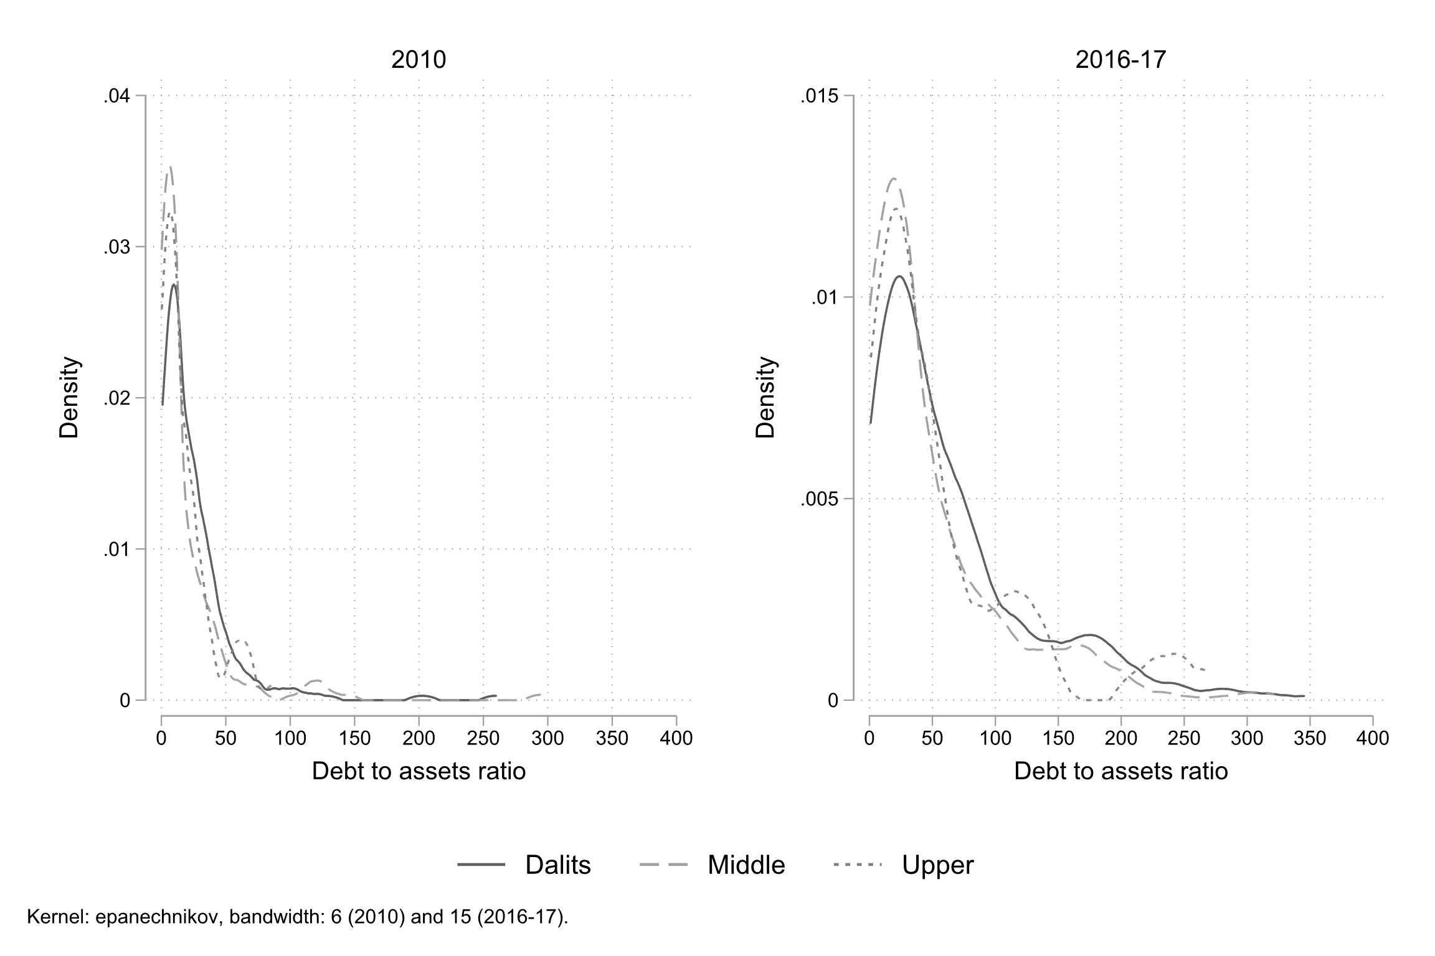

Figure 1: Kernel density of Debt to Assets Ratio by castes -- **Source**: RUME (2010) and NEEMSIS-1 (2016-17); author’s calculations

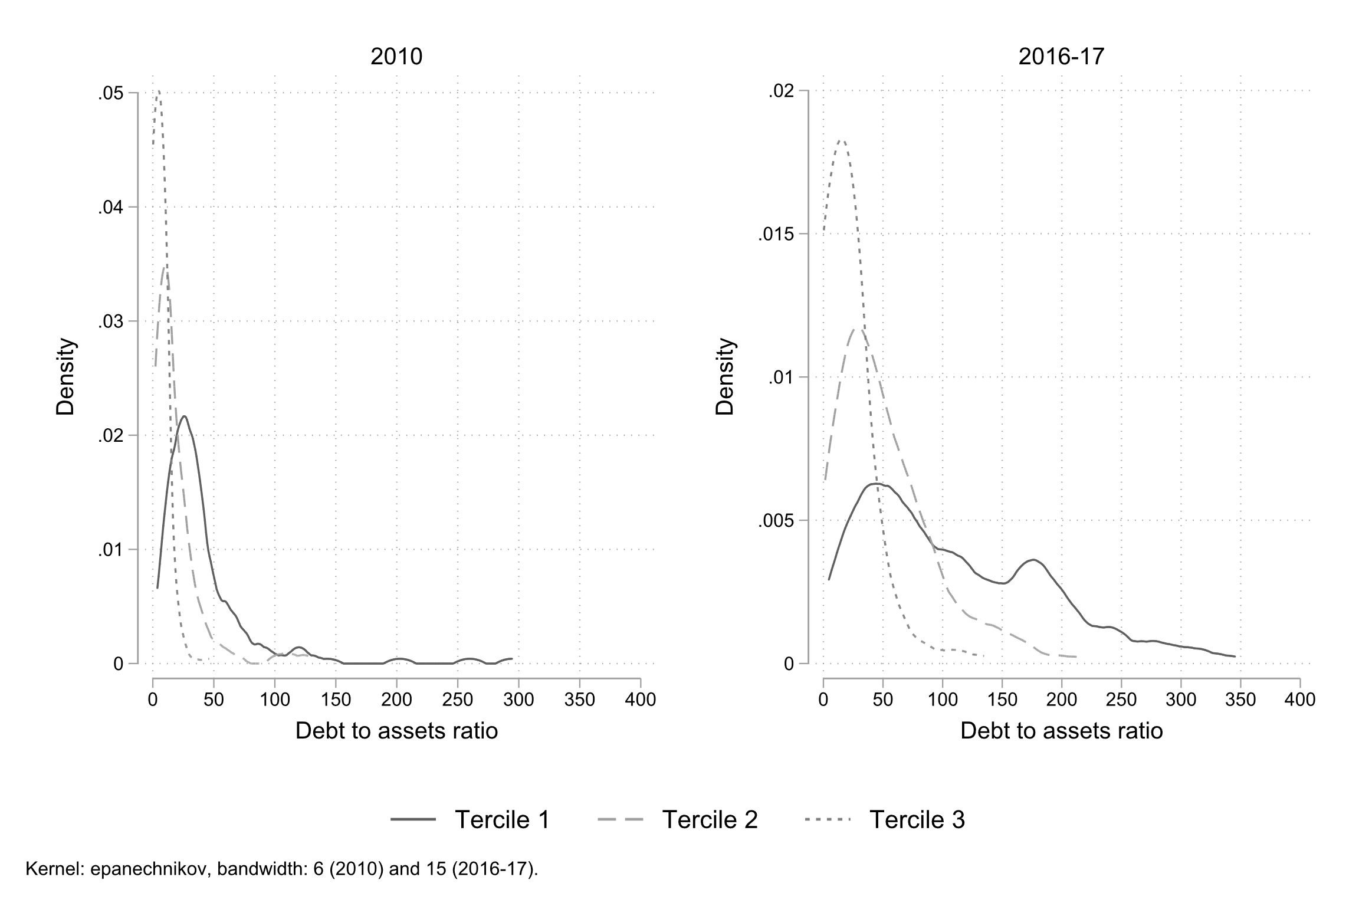

Figure 2: Kernel density of Debt to Assets Ratio by tercile of assets -- **Source**: RUME (2010) and NEEMSIS-1 (2016-17); author’s calculations

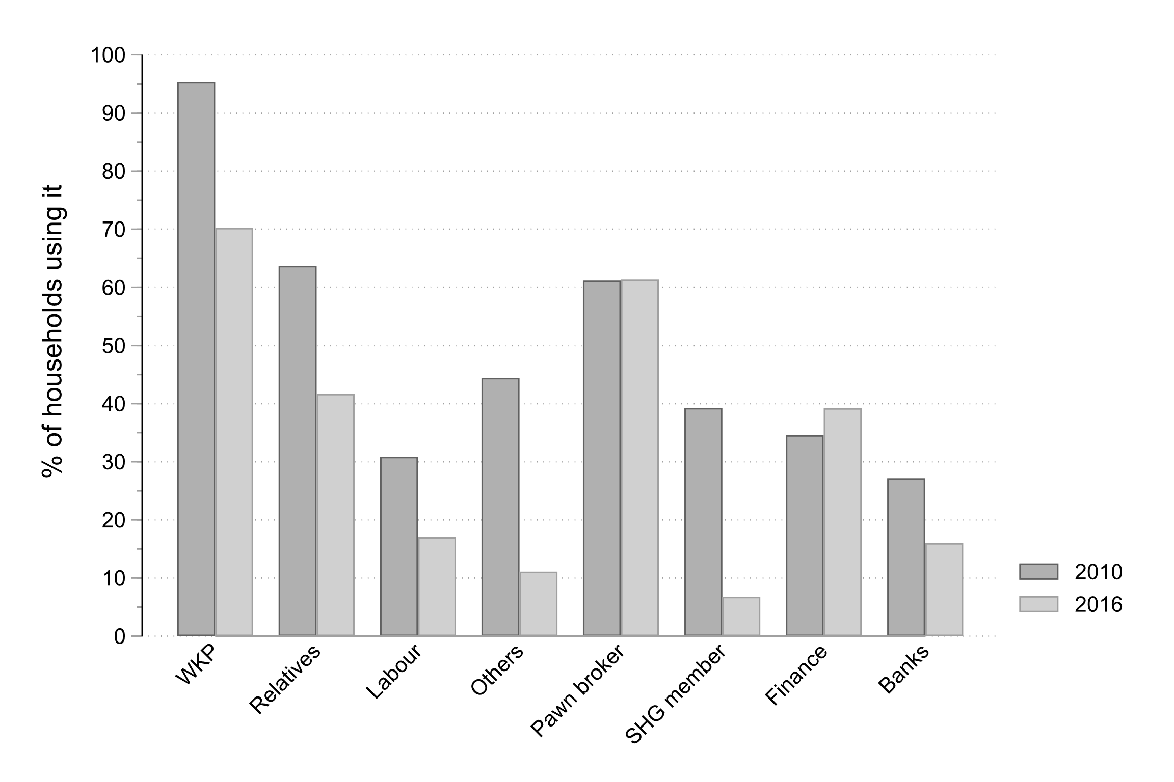

Figure 3: Source of borrowing (percent of users) -- **Source**: RUME (2010) and NEEMSIS-1 (2016-17); author’s calculations

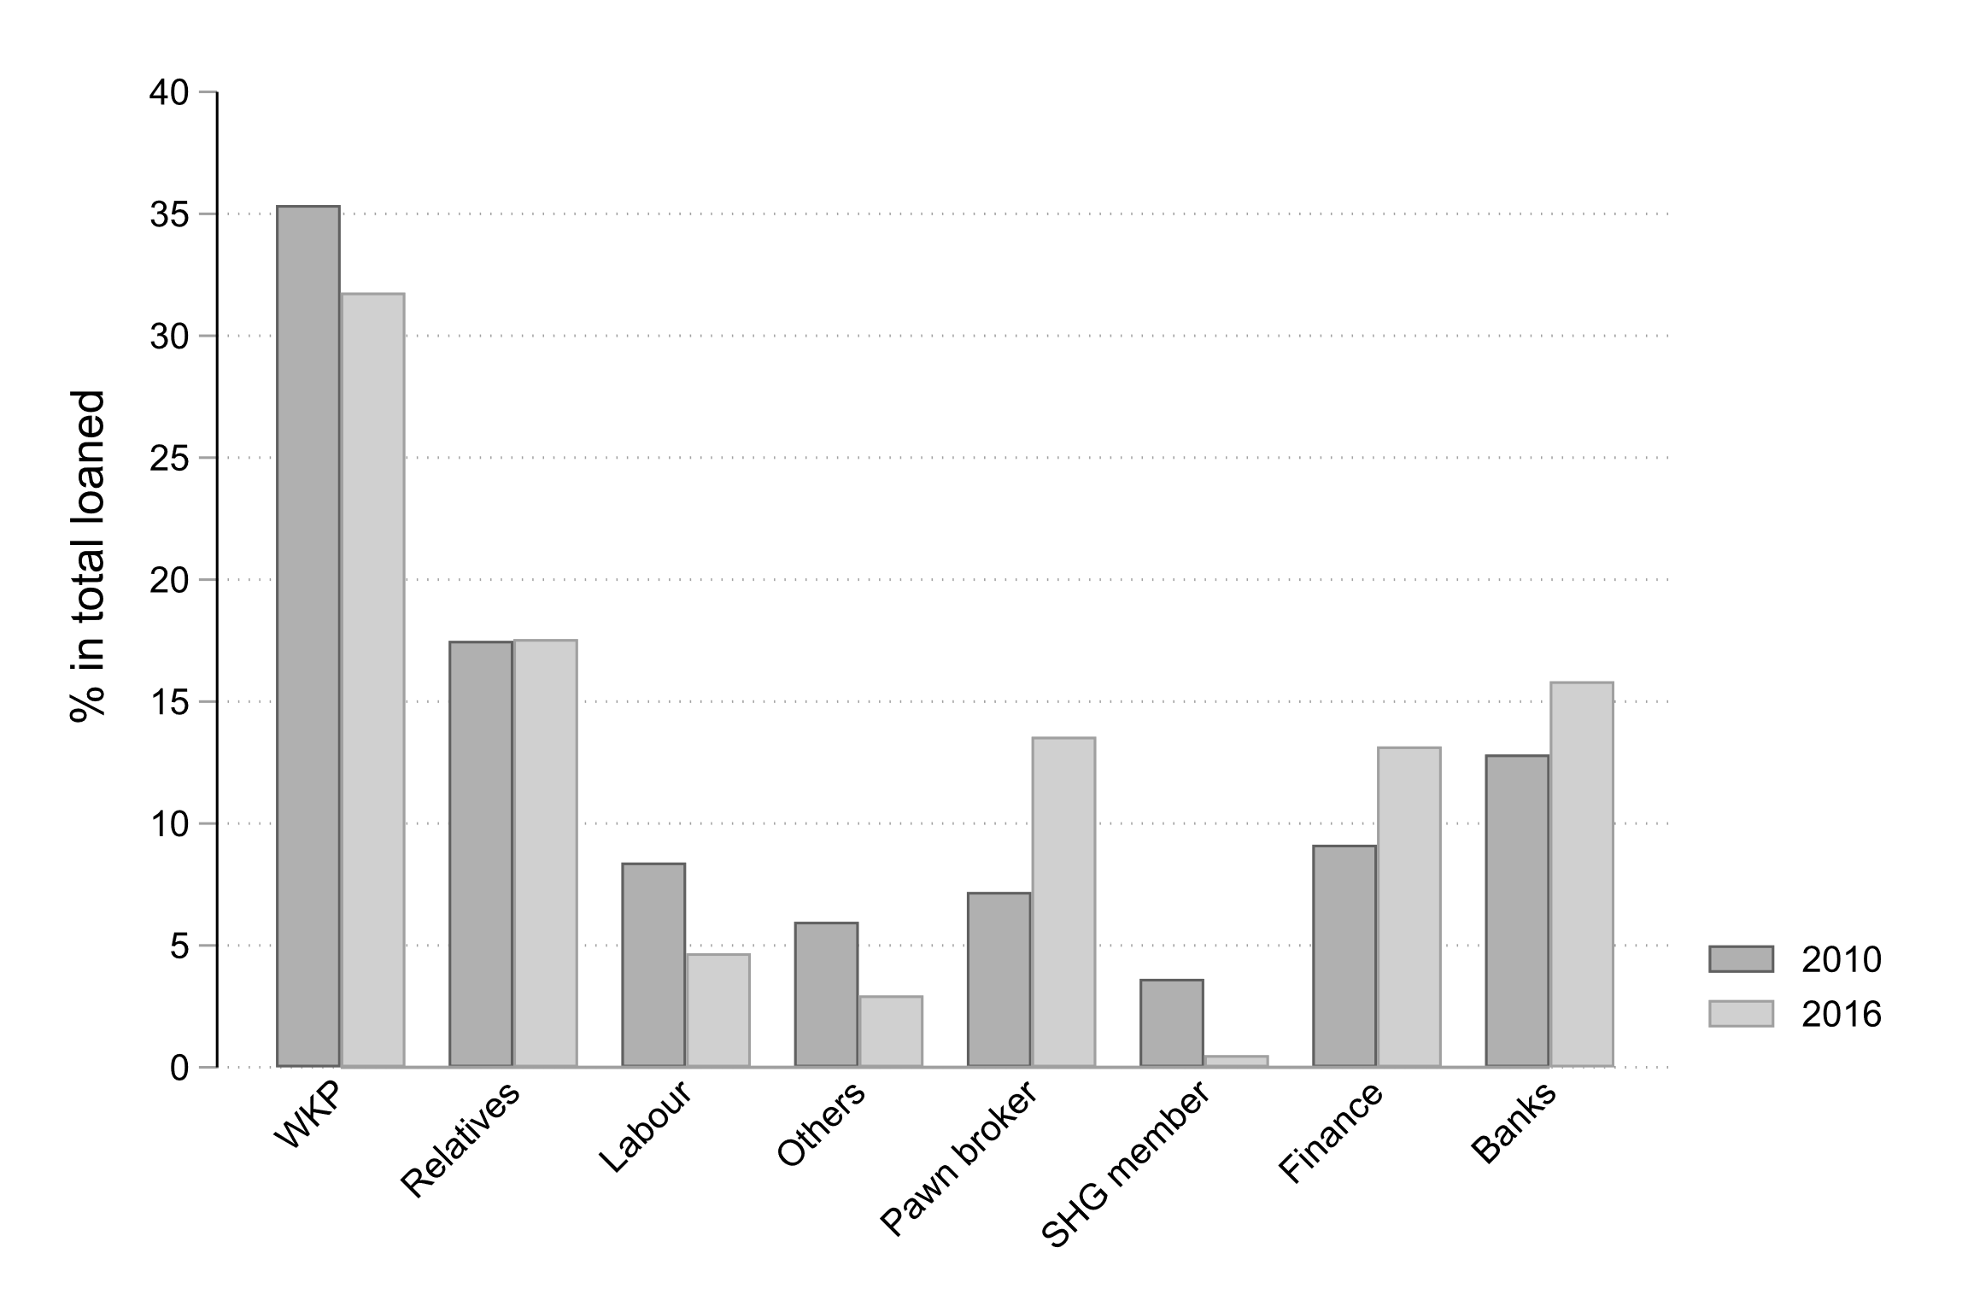

Figure 4: Source of borrowing (percent of volume) -- **Source**: RUME (2010) and NEEMSIS-1 (2016-17); author’s calculations

Table Loan sources by caste and ownership -- Source: NEEMSIS-1 (2016-17); author's calculations.

|  |  |  |  |  |  |  |  |
| --- | --- | --- | --- | --- | --- | --- | --- |
|  | Total |  | Dalits | Non dalits |  | Landowner | Landless |
| Number of household | n=487 |  | n=232 | n=255 |  | n=153 | n=334 |
| Informal |  |  |  |  |  |  |  |
| *WKP* | 70.2 |  | 70.3 | 70.2 |  | 68.0 | 71.3 |
| *Relatives* | 41.7 |  | 41.8 | 41.6 |  | 47.1 | 39.2 |
| *Labour* | 17.0 |  | 21.1 | 13.3 |  | 3.9 | 23.0 |
| *Others* | 11.1 |  | 11.2 | 11.0 |  | 11.8 | 10.8 |
| Semi formal |  |  |  |  |  |  |  |
| *Pawn broker* | 61.4 |  | 58.6 | 63.9 |  | 64.7 | 59.9 |
| *SHG member* | 6.8 |  | 6.9 | 6.7 |  | 5.9 | 7.2 |
| Formal |  |  |  |  |  |  |  |
| *Finance* | 39.2 |  | 44.4 | 34.5 |  | 40.5 | 38.6 |
| *Banks* | 16.0 |  | 9.0 | 22.3 |  | 28.1 | 10.5 |
| Note: In % of households | | | | | | | |

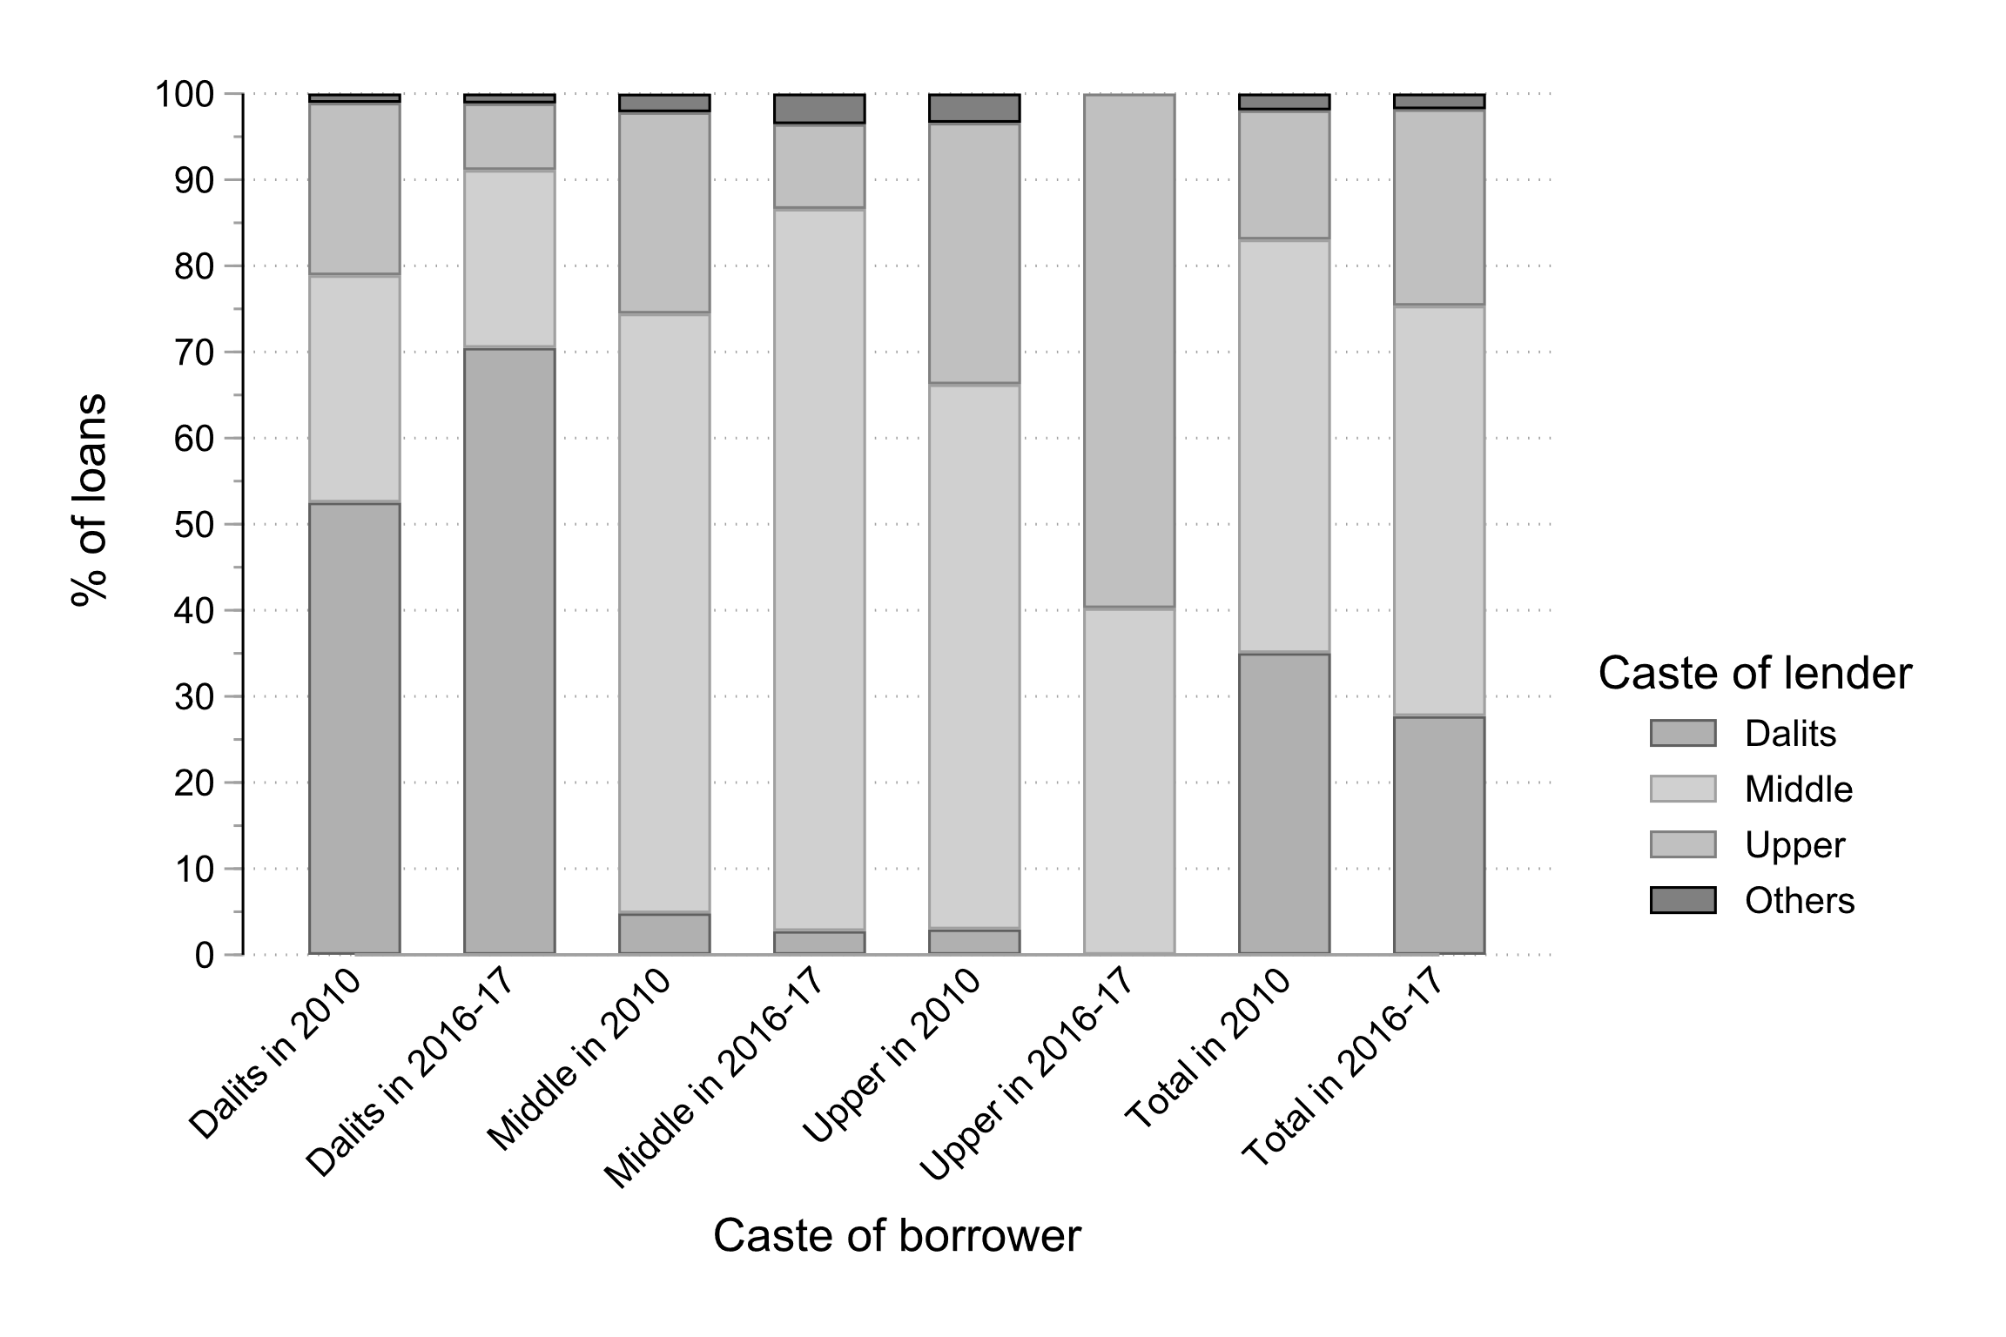

Figure 5: Debt and caste, who borrows from whom (percent of loans)? -- **Source**: RUME (2010) and NEEMSIS-1 (2016-17); author’s calculations

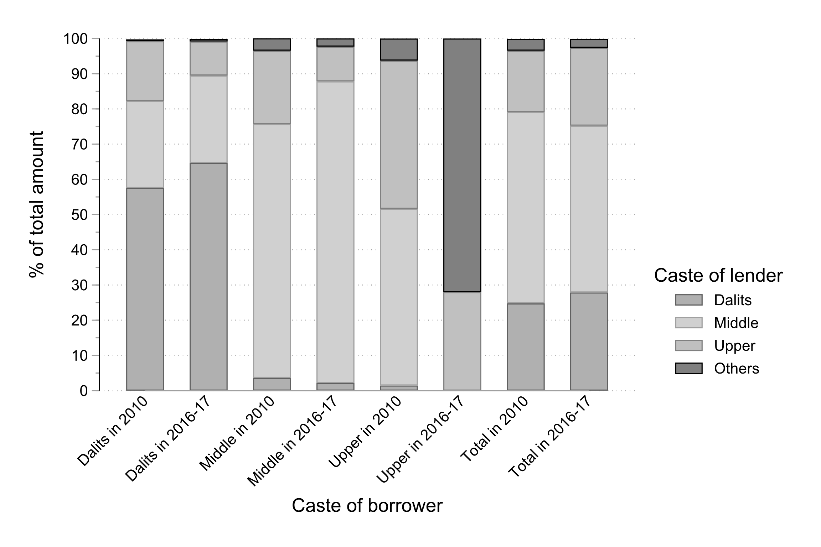

Figure 6: Debt and caste, who borrows from whom (percent of volume)? -- **Source**: RUME (2010) and NEEMSIS-1 (2016-17); author’s calculations